Remote lesson 6.2
Increasing and Decreasing Intervals, Symmetry, Range, Boundedness, Extrema, Limits

Determine the intervals over which the function is increasing and decreasing. Use open intervals unless the function has an endpoint. Remember intervals are x-values!

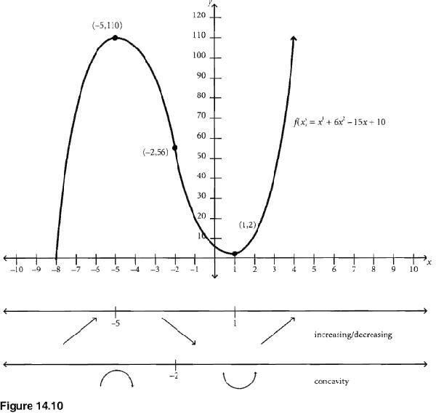Final answer: $Increasing: \left[-8,-5\right)∪\left(1,∞\right)$
$$Decreasing: (-5, 1)$$

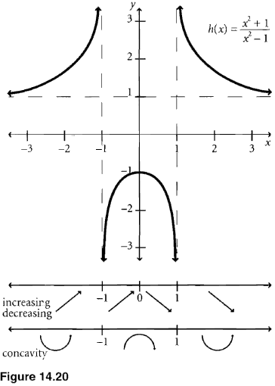

Final Answer: $Increasing (-∞, -1)∪(-1, 0)$
$Decreasing \left(0,1\right)∪\left(1,∞\right)$
*Remember you are looking at the x-values over which the function goes up and down as you read from left to right. Stay focused on the x-axis as you answer!

Symmetry

With respect to the y-axis: Algebraic: f(-x) = f(x)
Geometric: Looking at a graph, these are
Even Functions (Remember identities) opposite x values yield equal y-values

With respect to the origin: Algebraic: f(-x) = -f(x)
Geometric: Looking at a graph, these are
Odd Functions—opposite x values yield opposite y-values.

With respect to the x-axis: If (x,y) is on the graph (x, -y) is on the graph Not Functions

Please note: If for example an even function moves 4 to the right, we would use the term “line symmetry at x=4” as opposed to y-axis symmetry

Similarly, we would call it point symmetry if an odd power function shifted as opposed to origin symmetry

Ex) Determine the symmetry algebraically

1)
Start by finding f(-x) – take all x values and replace with -x
$f\left(-x\right)= {(-x)}^{2}+4$ Note the importance of parentheses when replacing x with -x
$f\left(-x\right)=x^{2}+4$ Simplify the expression.
Note that the right hand side of f(x) is the same as the right hand side of f(-x)
None of the signs changed when comparing the answers
Therefore f(-x) = f(x)
Final answer: this function has y-axis symmetry

2) $f\left(x\right)=-x^{3}-x$
$f\left(-x\right)=-({-x)}^{3}-(-x)$
$f\left(-x\right)=x^{3}+x$ notice ALL signs changed compared to f(x)
This function has origin symmetry

3)
$f\left(-x\right)=({-x)}^{4}-2\left(-x\right)+4$
$f\left(-x\right)=x^{4}+2x+4$
Some signs changed, some didn’t
Therefore this function has no symmetry

4)

$f\left(-x\right)= \frac{{(-x)}^{3}}{9-{(-x)}^{2}}$

$f\left(-x\right)=\frac{{-x}^{3}}{9-x^{2}}$

$f\left(-x\right)=-\frac{x^{3}}{9-x^{2}}$

The last fraction is the opposite of the original.
Therefore this function has origin symmetry

Range: The y-values generated by evaluating the function throughout the domain.
Geometrically: Graph and observe the y-values of the function
Algebraically: Find the inverse of the function and find its domain
$The range of f\left(x\right)=the domain of f^{-1}(x)$

Ex) Find the range of the function: For now, you can graph on your calculator if needed

- f(x) = x² + 3 This is a parabola whose vertex is moved up 3.
Final answer: y > 3 (book will say $[3, ∞))$

- g(x) = This is a square root function translated 4 units left
Final answer: y > 0
- h(s) = This function is vertically stretched by $\frac{\sqrt{10}}{3}$
Final answer All Reals

Bounded

Def. A function is bounded below if there exists some number, b, less than or equal to every number in the range of f. b is the lower bound.

Def. A function is bounded above if there exists some number, b, greater than or equal to every number in the range of f. b is the upper bound.

**A function is bounded if it is bounded above and below.

Extrema
A relative (local) maximum of f is a maximum value within an interval of a function. The absolute max of the function may also be a relative max, as long as it can be contained in an interval. To be a relative max, the function must increase to the point and decrease after.
Please give only the y-value here (so as not to confuse it with an interval)

A relative (local) minimum of f is a minimum value within an interval of a function. The absolute min may also be the relative min. To be a relative min, the function must decrease to the point and increase after.
Again, please give y- value

Extrema includes Max, min, relative max and relative min

Ex) Given f(x) = 2x⁴-5x²+2x, find all extrema (Use 2nd trace on TI)

local min: -5.453 and -1 min: -5.453

local max: 0.203 max: none

Limits: You have done these as $x→∞, y→ and x→-∞, y→$ we are simply changing the notation

Ex) Lets look at even power functions,

f(x)=x²
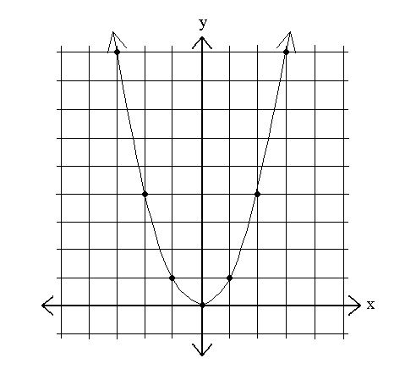
As x-increases, what happens to y?

limf(x)= $∞$ or limx²= $∞$
x-> ∞ x->∞
As x decreases?
limf(x)=$∞$
^{x->-∞}

Think of f(x) and y as the same thing. The first statement is read
“the limit of f(x) as x approaches infinity”

Ex) Odd power
f(x)=x³

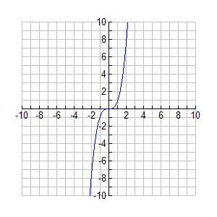
limf(x)=$∞$
^{x->∞}

limf(x)=$-∞$
^{x->-∞}
End Behavior: when asked for end behavior you will need to write and find both $\lim_{x→∞}{f(x)} and \lim_{x→-∞}{f(x)}$

Analyzing a Function: when you are asked to analyze a function, you will need to answer the following
- Domain: Use Interval Notation
- Range: Use Inequalities
- Increasing and Decreasing Intervals: Answer inc: dec:
- Continuity: Answer “continuous” or something like “essential discontinuity at x= “
- Symmetry: Answer “y-axis”, “origin”, “line at x=”, or “point at (x,y)”
- Boundedness Answer “above”, “below”, “bounded” or “not bounded”
- Extrema Address max, min, rel max, rel min (y-values)
- Asymptotes Both vertical and horizontal
- End Behavior $\lim_{x→∞}{f(x)} and \lim_{x→-∞}{f(x)}$
- Graph: If not given to you, graph using a minimum of 3 anchors

On the next page a graph is given, the analysis would look like this
- Domain: $(-∞,∞)$
- Range: y > -75
- Increase: $(-2,1)∪(4,∞)$ Decrease $(-∞,-2)∪(1,4)$
- Continuous
- No Symmetry
- Bounded below
- No max, min: -75, rel max: $≈35$, rel min: $≈-35 and-75$
- No asymptotes
- $\lim_{x→∞}{f(x)}=∞ and \lim_{x→-∞}{f\left(x\right)=∞}$

Example Analyze the graph
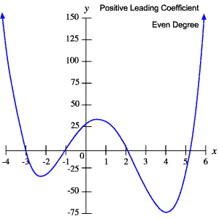

HOMEWORK: P 98 (1-53 Every other odd) Use a calculator when needed to look at graphs

