Pre-Calc Area of a Triangle
Area of a Triangle
You already know this formula for the area, K of a triangle: $K= \frac{1}{2}bh$, where b is the base and h is the height.

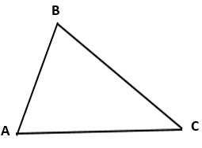
Consider $∆ABC$ in Figure 1.
1. AB = 31 cm, AC = 42 cm, BC = a, $m∠A=57°$ and the height
Figure 1
of the triangle from vertex B to the side AC.
Find the height, h.
$$sin57°=\frac{h}{31} , h=31sin57°, h≈25.999$$
2. Find the area of the triangle to the nearest ${cm}^{2}$.
$K= \frac{1}{2}bh$, so $K=\frac{1}{2}42(31\sin{57°)}$, or if you still have your answer in your calc, $K=\frac{1}{2}42(ans)$
$K≈546 {cm}^{2}$

3. a. Fill in the value you used for the base, b. b =__42___________
b. Show how you calculated the height. h = ____$31sin57°$________
Put your answers from a. & b. into a single equation which shows how you calculated the area, K using the side(s) and the angle(s) of the triangle.
K = $\frac{1}{2}bcsinA$ Notice the values given create a SAS given
Figure 2

Consider the $∆ ABC$ in Figure 2
In the triangle $m∠A=61°$ and $m∠C=78°$, AC = 37 in., BC=a
AB = c and the height is from vertex B to side AC.
4. Find the area of the triangle to the nearest ${in}^{2}$.
Notice this given is AAS. If we can find a measure to create a SAS, we can solve like above
To create SAS, we need to find a side, so law of sines will be first step.
So we know $B=41°$. So, $\frac{37}{sin41°}=\frac{a}{sin61°}$ (we could also have used C and c instead. Either is good)
So, $a≈49.326 in$ (again, keep this value in your calculator so we may use Ans feature)
We can now create a SAS having values for a, b, C
Like the formula in #1, ours will be $K=\frac{1}{2}absinC$
$$K≈893 {in}^{2}$$

5. Did you need to find any of the unknown dimensions of this triangle in order to calculate the area (i.e. side c, side a, or angle B)? If yes, which dimension(s) and why?
We found B so that we could use Law of Sines. We used the Law to find a to create a SAS
6. Think about side(s) and angle(s) which were required to calculate the area of Figures 1 and 2. Within each triangle, what is the relationship of the side(s) to the angle(s)?
This question simply emphasizes that our goal is to create SAS
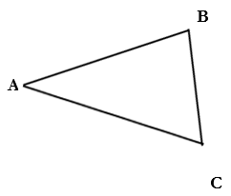
Consider $∆ABC$in Figure 3
Figure 3

AB = 19.2 cm, BC = 11.3 cm, AC = b, $m∠B=87.3°$.
$$think c=19.2cm a=11.3cm$$
7. If you drew the height from A to $\overline{BC}$
What is the value you would use for the base?
b = ___11.3_____________
Show how you would calculate the height.
h = $19.2sin87.3°$________________
8. If you drew the height form C to $\overline{AB}$
What is the value you would use for the base?
b = ___19.2___________
Show how you would calculate the height.
h = ____$11.3sin87.3°$__________
9. Using your answers from #7 and #8 above, write the two equations that you could use to calculate the area, K using the side(s) and angle(s) of the triangle.

From #7 : K = $\frac{1}{2}acsinB$
From #8: K = $\frac{1}{2}casinB$
10. What do you notice about the two equations? same
Was is important where you drew the height? No, as long as it’s not through the given angle

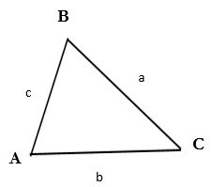
Consider the $∆ABC$ in Figure 4
Figure 4

11. Write 3 equations that could be used to calculate the area of this triangle.
One equation should use angle A, anouther should use angle B, and the
third should use angle C.

Using angle A: K = $\frac{1}{2}bcsinA$
Using angle B: K = $\frac{1}{2}acsinB$
Using angle C: K = $\frac{1}{2}absinC$

Can you put into words the strategy that you would use to find the area of a triangle with an unknow height? (Discuss this with your partner) If not already given, find the measures necessary to create a SAS given, then use one of the 3 above formulas (please notice these are all the same formula, similar to the 3 versions of the Law of Cosines.)

Here is another formula you can use to find the area, K of a triangle. This formula is names for Heron who lived in Egypt from about 10-70 AD and whose proof of this oldesr in record.
Heron’s Formula: $\sqrt{s(s-a)(s-b)(s-c)}$
where a,b & c are lengths of the sides and s is the semiperimeter = $\frac{(a+b+c)}{2}$

12. Find the area of $∆ABC$ where AB = 5 in, BC = 7in and AC = 9 in.

$s=\frac{5+7+9}{2}=10.5$ so $K=\sqrt{10.5(10.5-7)(10.5-9)(10.5-5)}$
$K≈17 {in}^{2}$

13. Without using Heron’s formula, how else could you find the area of the triangle in #12? Do not do it, just describe how it can be done.
With a SSS given, we could use Law of Cosines to solve for any of the angles. We would then create a SAS and use one of our earlier formulas.

14. On Sunday afternoon in Charlotte, NC, the Pittburgh Steelers were playing the Carolina Panthers. At the start of the game, the Panthers kicked off from their own 35 yard line. The ball flew 73 yards and was caught by Ryan Switzer. Switzer started running at some angle from the line of the kick and ran for 12.5 yards before being tackled. The perimiter of the triangle formed by the point of the kick off, the catch and the tackle. Is 150.5 yards. What angle was formed between the line of the kick and the path of Ryan Switzer?
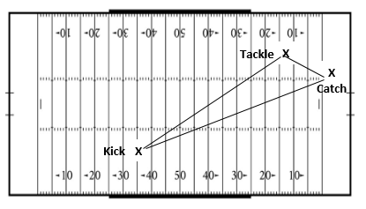

So our goal is to find the Catch angle. The most sensible thing to do here would be to find the remaining side by taking the perimeter and subtracting the 2 given sides. 150 – 73 – 12.5 = 64.5
So in theory we have $a=73, b=12.5, c=64.5$ given to find angle C

$$Law of Cosines c^{2}=a^{2}+b^{2}-2abcosC$$
$${64.5}^{2}={73}^{2}+{12.5}^{2}-2\left(73\right)\left(12.5\right)\cos{C}$$
$$4160.25=5485.25-1825cosC$$
$$-1325=-1825cosC$$
$$\frac{1325}{1825}=cosC$$
$C=\cos^{-1}\frac{1325}{1825}$
$C≈43.45°$

