Homework Set #2.2 (101pts) Name
Please do all of your work on a separate sheet of paper.
You may use this sheet as an answer sheet if you choose to.

I. Write two equations for each graph, one using sine and the other using cosine(5 pts each)
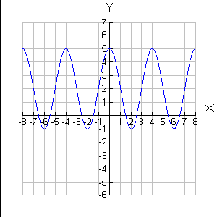

1.

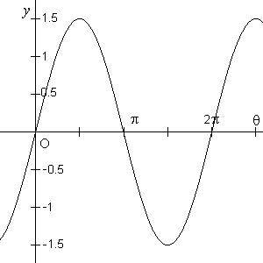
2.

II. Sketch at least two cycles of each curve (15 pts each)

  - $y=\tan\left(2x\right)$
  - $y=\tan\left(x+\frac{π}{4}\right)$
  - $y=3secx$
  - $y=-cotx+1$
  - $y=csc⁡(3x)$

III. Identify the amplitude, period, phase shift, and vertical shift for each. (4pts each)

- $y=-3tan2x+1$
- $y=sec⁡(3x-π)$
- $y=4cscπx$
- $y=2\cot\left(-3x+1\right)-4$

