**Homework Set #1.1** Name

*Please turn in your answers and work on a separate sheet of paper.*

*Staple this sheet on top.*

1. Convert revolution to a) degrees b) radians

1. 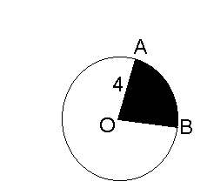Convert 210° to radians exactly
2. If  find :
3. the length of AB
4. the area of the shaded region

**In #4-6 give the value to the nearest thousandth**

1. sin 35°
2. tan (-6)
3. cos 36° 50’

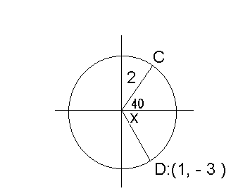

**In #7 and 8 refer to the circle of radius 2 *(angle measures in degrees)***

1. Give the coordinates of C
2. Give the measure of *x* in degrees
$$°$$

$$(1, -\sqrt{3} )$$

3. What angle does the line  make with the x-axis? (Explain ans.)
4. What angle does the line  make with the y-axis?

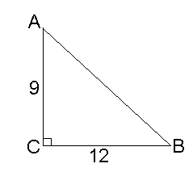

**Use the triangle for #11-12**

1. Find tan B (exactly)
2. Find sec A (exactly)

**Homework Set #1.2 Name_____________________**

*Please turn in your answers and work on a separate sheet of paper.*

*Staple this sheet on top.*

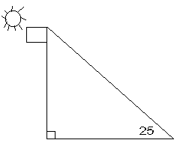1. A flagpole casts a shadow 50ft. long when the angle of elevation to the sun is 25°. How tall is the flagpole?

$$25°$$

**In #14-16 find exact values**

2. cos 120°

3. sin 

4. tan 

5. Given a triangle with a = 5, b = 6, and = 80°. Find the length of side c to the nearest hundredth.

6. In , AB = 20, BC = 40, and AC = 30, Find .

**In 7-8, find the measure of *x*. For #19, round the measurement to the hundredths place. For #20, give your answer in degrees rounded to the nearest minute.**

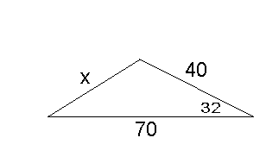

7.

$$32°$$

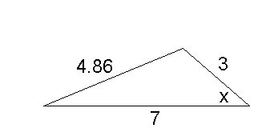8.